OSM 1.0 Document Fill & Sign Guide
To complete the OSM 1.0 document, please complete the Data Entry Form which is the first page of the document, all fields marked in red are compulsory & must be completed. This will then auto populate the rest of the document;
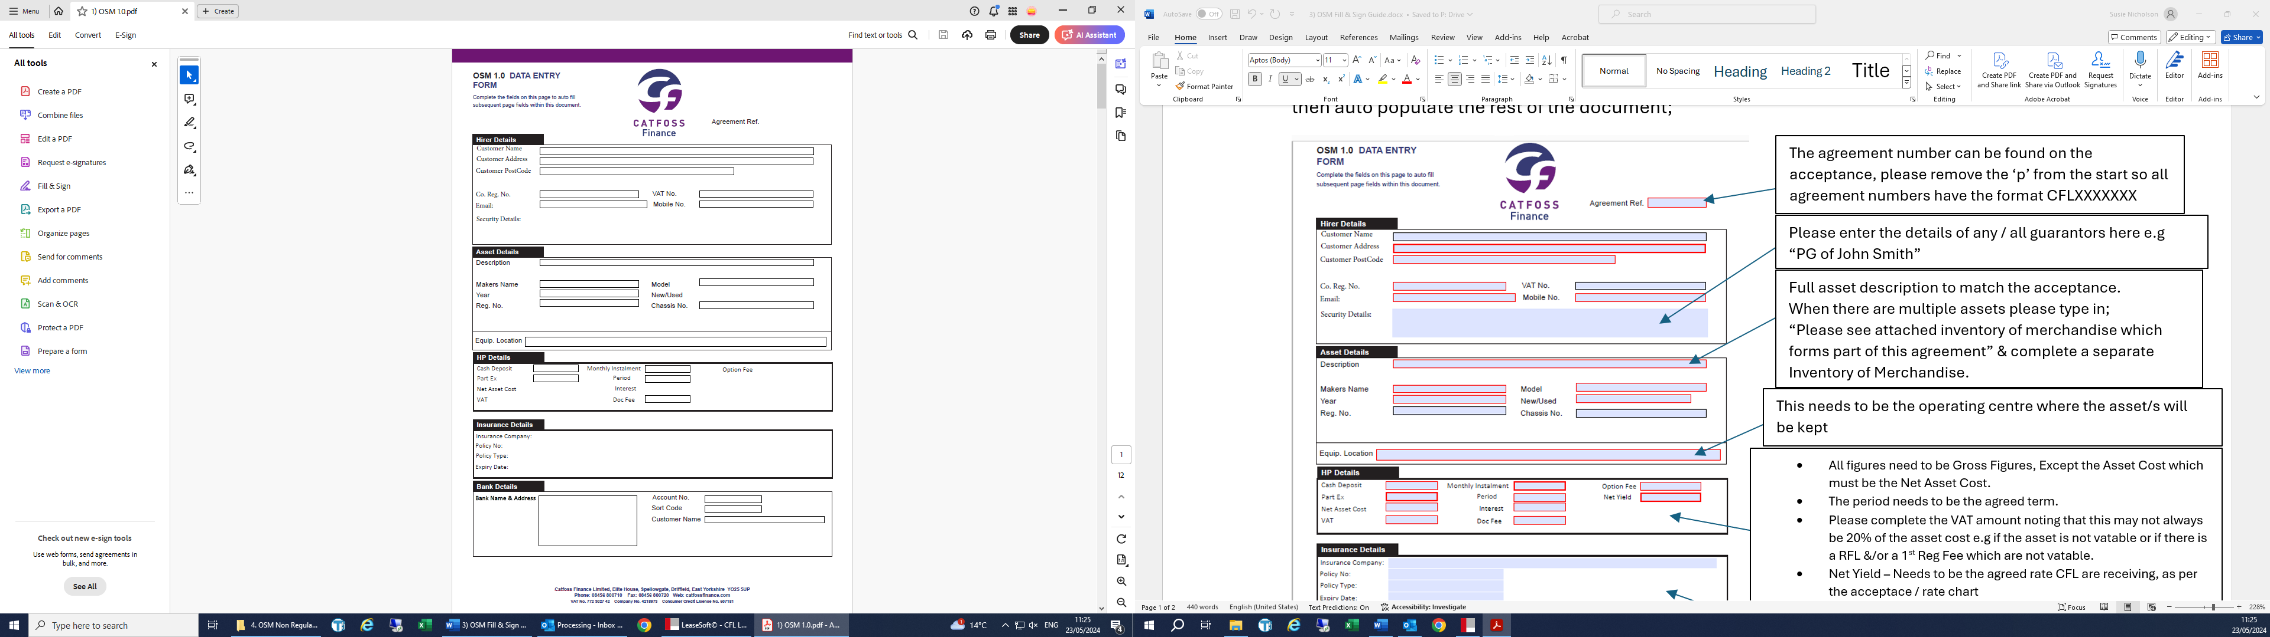
- All figures need to be Gross Figures, Except the Asset Cost which must be the Net Asset Cost.
- The period needs to be the agreed term.
- Please complete the VAT amount noting that this may not always be 20% of the asset cost e.g if the asset is not vatable or if there is a RFL &/or a 1st Reg Fee which are not vatable.

Insurance details need to be entered here if we have them at this stage, if not the customer will need to manually fill these details in on page 2 when they sign the document.
Bank details to be completed if we have them at this stage, if not the customer will need to manually fill these details in on the direct debit mandate when they sign the document
This needs to be the operating centre where the asset/s will be kept
Full asset description to match the acceptance.
When there are multiple assets please type in;
“Please see attached inventory of merchandise which forms part of this agreement” & complete a separate Inventory of Merchandise.

Please enter the details of any / all guarantors here e.g
“PG of John Smith”
The agreement number can be found on the acceptance, please remove the ‘p’ from the start so all agreement numbers have the format CFLXXXXXXX

*Please Note* Catfoss offer a document checking service, completed documents can be emailed to processing@catfossfinance.com for checking prior to signing. Any incorrect documents sent in after signing will cause delays at payout.

OSM 1.0 How to print
Please print pages 2-12 to take to the customer for signing. The customer does not receive a copy of the Data Entry Sheet. If emailing to the customer for them to print off & sign, please print pages 2-12 as a PDF so that the document cannot be altered.

OSM 1.0 – Where to sign

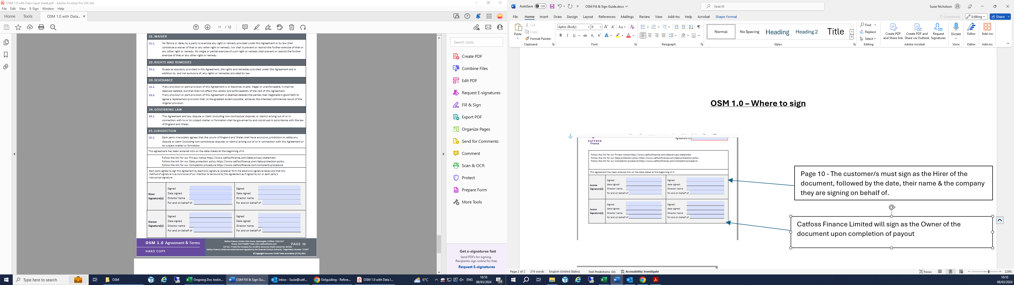
Catfoss Finance Limited will sign as the Owner of the document upon completion of payout
Page 10 - The customer/s must sign as the Hirer of the document, followed by the date, their name & the company they are signing on behalf of.

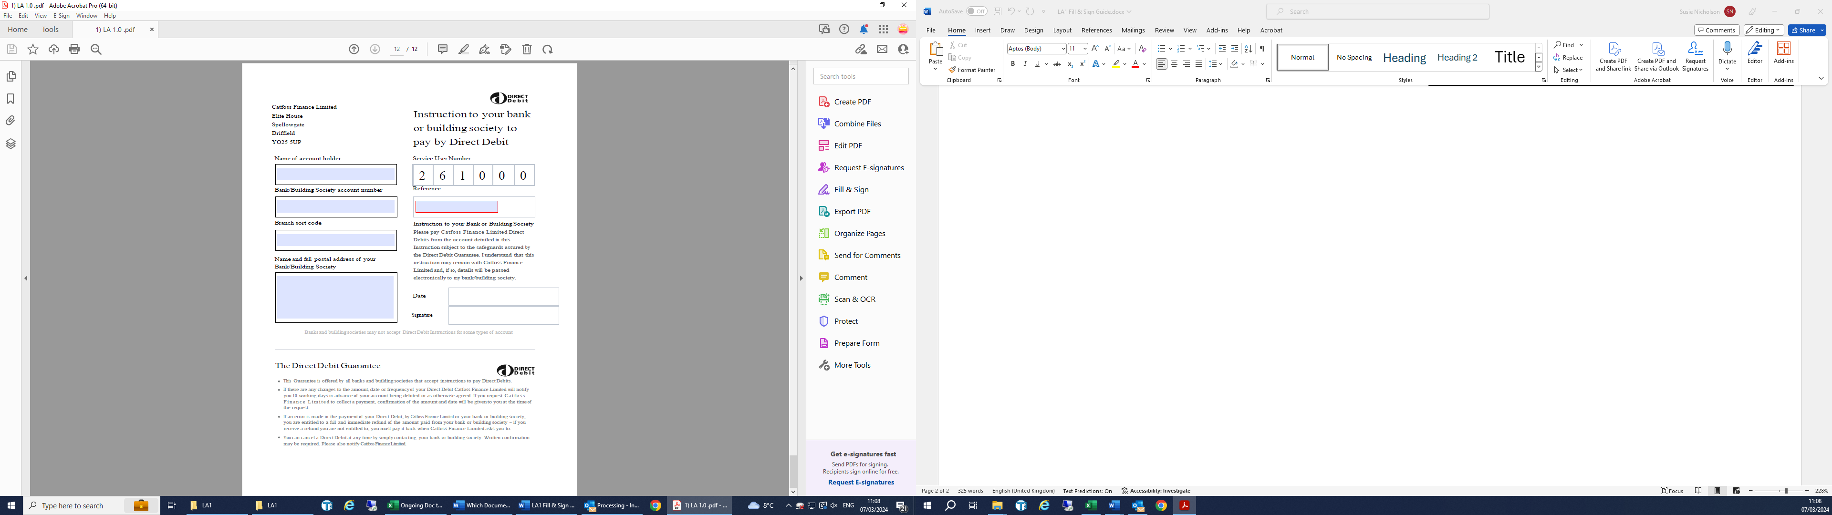
Direct Debit Mandate needs to be signed & dated by anyone with authority to do so on behalf of the company

